RUSSIAN WONDERS
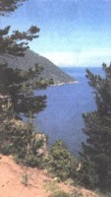
Although our country doesn’t take leading positions in the world tourism, there are still lots of entertaining places to visit. More than a half of Russian territory is covered by forests. So without any doubt we can say that there thousands of
wild places and reserves with interesting flora and fauna and unspoilt nature. Everyone knows about Lake Baikal – the deepest freshwater lake in the world. It’s also a unique locked ecosystem. Lots of species of bacteria, fishes and animals exist only on the Baikal’s territory. Its wonderful climate has managed to save many disappearing creatures since the Ice Age. But not only the Baikal Lake is a piece of wild nature, it’s also a rather popular place to visit. Three reserves and two national parks are situated on its territory. Many people believe that Baikal’s freshwater has a special healing ability. So many tourists from all over the world come there to enjoy the unspoilt beauty of nature and to try to cure some diseases, even hereditary ones.
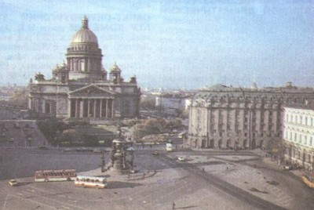
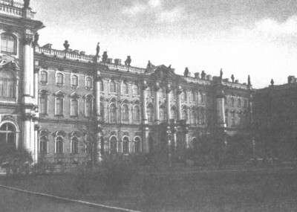
Now a few words about another part of our country. To tell you the truth, there are not many world-class cities in Russia. But in my opinion one of them is worth visiting. I’m talking about our northern capital, the second largest cultural and industrial center of our country – St. Petersburg. The views of this city are really impressive. St. Petersburg is also called “The City of Tsars”. That’s because of its being the capital of Russia for a long period of time. Because of that there are lots of beautiful royal palaces and residences with their elegant architecture and wonderful parks and gardens. Moreover, there are lots of temples and churches with world-famous icons. Thousands of believers from all corners of the world come there to adore them. This city is also famous for its great art galleries. For example the Hermitage, which attracts crowds of art lovers every year and the Russian Museum, which has a large collection of arts and things of the royal family too.
St. Petersburg has one of the largest sea ports in our country - it is situated on the Baltic Sea. So it won’t take you much time to get to one of our native world wonders – Valaam Islands – the most wonderful and mysterious place in Russia. Valaam Islands are a group of islands in the Ladozhsky Lake in Korelia where the largest men’s monastery in Russia is situated. This monastery is famous among believers all over the world. It was founded in the 14th century by Greek monks Sergey and German. Since that it had been attacked many times by Swedish and Finnish armies. But Valaam’s monks managed to survive and protect their valuable sacred things. Anyway, during the period of the Soviet-Finnish war that holy territory was occupied by the Finnish army. All monks were killed.
Nowadays Valaam Islands have a fame of a “place of wonders”. People who come here get rid of different diseases. Blind people start seeing and paralyzed ones begin to move. Holy water from this place has lots of extraordinary abilities and many other wonderful things happen there.

Aleksey Boltunov 11V
Teacher Savchenko O.A.

