RUSSIAN WONDERS
One of the most interesting places in our country is Lake Baikal. Its views, when you are passing by in a train, are really breathtaking that’s so because of untouched beauty of the Baikal. Lake Baikal is one of the greatest things we have in our country. Its depth is about 1600 meters and its holds of water are unbelievable. Wildlife is teeming here and you can see many interesting species of exotic flora and fauna. It is so because of the specific ecological situation and untouched eco-system of the lake. There are several resorts and national parks near the Lake and people always come here to improve their health with unquestionably clear water of The Lake.
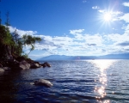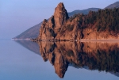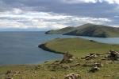
The second wonder is Moscow. Yes, I mean Moscow, the capital of the Russian Federation. Many people would like to visit it and many live here. Its population is about 9 millon at night and 13 – at day. Moscow is a big city with lots of bustling streets and busy prospects, cars and traffic jams. But there are also many great historic buildings with dramatic architecture. One of them is The Twelve Apostles Church that you can see in the left bottom photo. There are many theatres in Moscow, The Bolshoy Theatre for example. World-class art galleries are also present. But the most fascinating and stunning thing is Saint Basil’s Cathedral (bottom right). It is one of the symbols of Moscow for tourists that come here. If you haven’t visited Saint Basil’s Cathedral – you haven’t been to Moscow, so foreign tourists say.
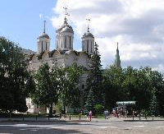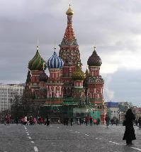

Fyodor Fedorenko 11M
Teacher Savchenko O.A.

