Russian Wonders.

St. Petersburg.
In my opinion, it is the most magnificent city in Russia. It used to be the capital of Russia and each ruler of the country tried to make it more and more beautiful. The Town-on-Neva looks amazing. You can spend the whole day, admiring elegant architecture, the number of historic buildings, whose noble ancient look creates a unique romantic atmosphere. But not only the beauty of the city attracts millions of tourists every season. There are plenty of churches, exhibitions and galleries, so the lovers of history, religion and art will definitely find something new to them. I would like to mention the world-class art-gallery Hermitage, which is famous all over the world and for sure, is worth visiting.
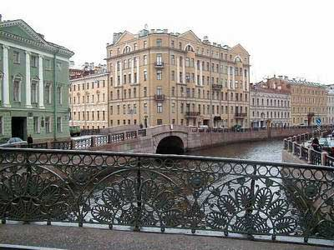

Krasnoyarsk Pillars.
I suppose that this place is worth seeing. Huge rocks look like stone giants and create dramatic scenery. If you climb over one of them, you’ll be able to see the whole town below. This view is really breathtaking. Krasnoyarsk Pillars are an ideal place for adventure sports lovers. Climbing over the rocks, enjoying picturesque scenery - isn’t it wonderful? Besides, Krasnoyarsk Pillars are surrounded by old giant trees, and teaming wildlife is also amazing. The only disadvantage is that people who are not physically fit get exhausted and are not able to feel all the joy of being in this place. There are some places of attraction in Krasnoyarsk itself- for example, hotel “Kolos”.
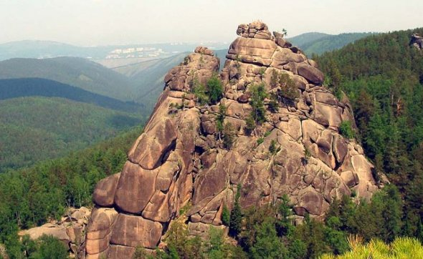

Moscow.
Moscow is the modern capital of Russia and doesn’t have such an “ancient spirit” like St. Petersburg does. The buildings are mainly modern, in hi-tech style. The population in Moscow is enormously high, so the streets are really bustling. In addition, Moscow has a lively nightlife, just like most of world capitals. Of course that doesn’t mean there are only skyscrapers and clubs in Moscow. There are plenty of places to go sightseeing, lots of exhibitions, galleries and spectacular buildings as well. Moscow in Russia is just like New York in the USA. What I want to say is that it attracts people a lot. Many people come to the city every year to find their way in life or to find a job. Besides, lots of young people come to get a university degree, because a great number of prestigious universities are situated in Moscow.
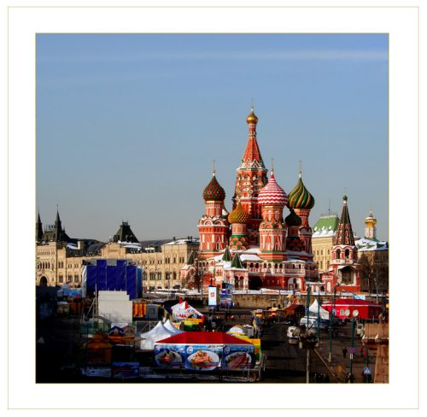
Elena Korsukova 11M
Teacher Savchenko O.A.

