Russian wonders

Although many people think there are no interesting places in Russia, in my opinion, our country is full of wonders.
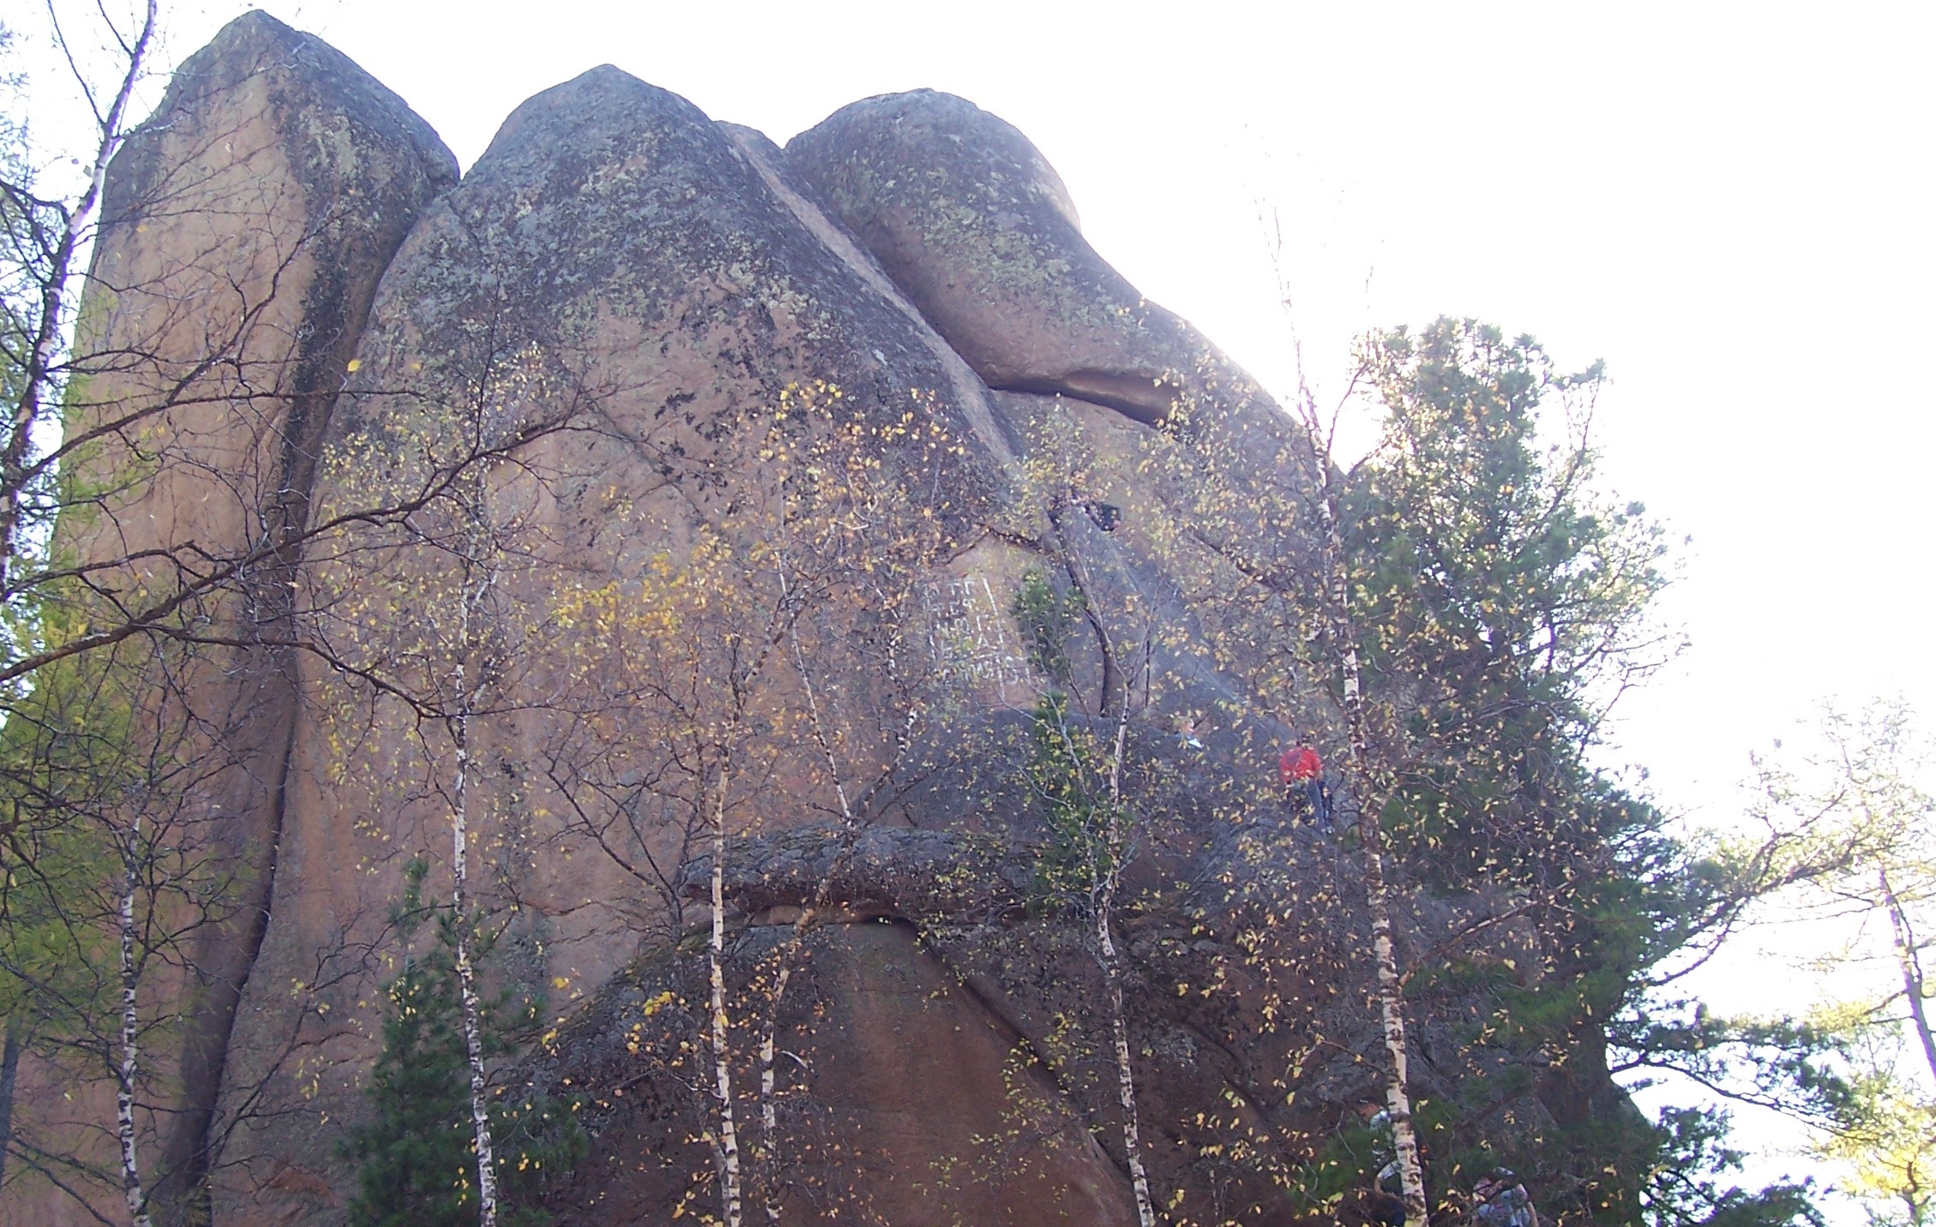
For example, Krasnoyarsk Pillars is a unique world-famous place. For a long time it had been unknown for scientists and only the natives had been worshiping them. However, in 1842 the famous geologist Chihachev described these dramatic natural pillars. Moreover, in 1851 the first man climbed up one of the pillars. After that, this place became a favorite one for the young to spend their free time.
Nowadays, Krasnoyarsk Pillars is a large reserve, the territory of which includes the pillars and unspoilt forests with interesting flora and fauna. Many people go to Krasnoyarsk Pillars every year, because, firstly, it is ideal for adventure sports and secondly, Krasnoyarsk Pillars have spectacular scenery and very romantic atmosphere.

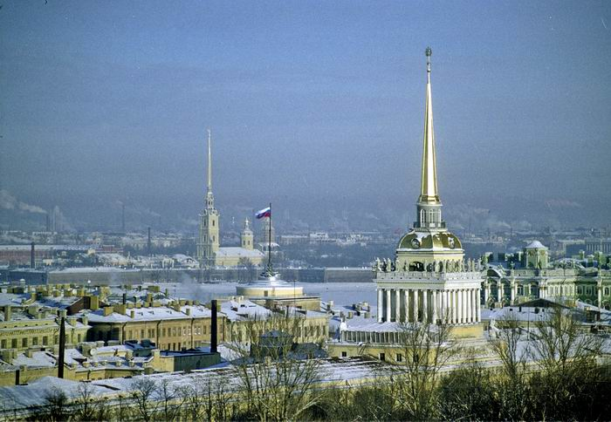
Now a few words about cities. I think the most wonderful one is St. Petersburg. For a long time it had been the capital of the Russian Empire, and now it is the second cultural and industrial centre of Russia (after Moscow, of course), it’s a big city with noisy bustling streets and quick modern life.
St.Petersburg is rather young, but it is famous for its historic buildings and spectacular examples of elegant architecture of the 18-19th centuries among them. It must be interesting to visit palaces, world-class art galleries, like the Hermitage, and numerous theatres. To be honest, many tourists go to Saint Petersburg only in order to see white nights. It is natural, because at those nights the city is breathtaking.

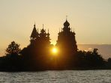
Maybe, the most “Russian” wonder is Kizhi. It is an island on the Onega Lake and the museum of Russian wooden architecture as well. Preobrazhenskiy church, elegant tented belfry and other spectacular buildings form a breathtaking architectural ensemble, which is surrounded by unspoilt northern nature. Tourists from different countries all over the world visit Kizhi in order to feel the romantic atmosphere of the island and understand the mystery of Russian soul.
Anna Polyakova, 11M Teacher – Savchenko O.A.

