RUSSIAN WONDERS.
Tomsk.
Population: 487,838 (2002 Census).
Tomsk is a city on the Tom River in the southwest of Siberian Federal District, Russia, the administrative centre of Tomsk Oblast.

Tomsk is well-known for its carved wooden houses: be sure to stroll along its old streets. Unfortunately, the quantity of these wooden houses is constantly decreasing due to fires and new construction. However, it is very unusual architecture for modern cities.
Everywhere you look you will see exciting cityscapes and architectural panorama. In my opinion, the creators of this beauty were really talented.

But Tomsk is not just history and elegant architecture. It has also exciting shopping opportunities and a lively nightlife; discos, clubs, all await nighttime visitors: Tomsk is the city of the youth. Students form the major group of population (more than 50%).

Tomsk has a number of prominent universities:Tomsk State University was the first university in Siberia (founded in 1878). The prominent Tomsk State University library book reserve is considered to be among the richest in Russia.
Tomsk Polytechnic University which opened in 1900 is the first technical university in Siberia.
There are also Tomsk State Pedagogical University, Tomsk State University of Architecture and Building and others.

Tomsk has many local cultural institutions including drama theaters, a children's theater and a puppet theater.
The city also has centers of German, Polish and Tatar culture where residents can study languages or learn about other countries.

You can spend a very exciting day walking around Tomsk waterfront. Take a ride on a boat and enjoy breathtaking views from the water...
Visit Central Park and watch street performers, people playing, and having a good time: it is always full of people who are enjoying life.

Your eye will be captivated everywhere you look: parks, fountains, gardens and historic buildings will make each excursion a real pleasure.
Its exotic markets, its unusual shops, its beautiful art and its wonderful restaurants make Tomsk difficult to leave.
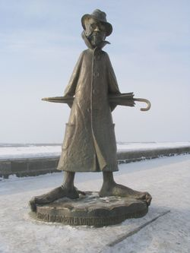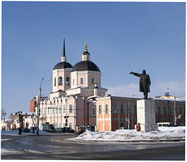
Ironical monument to Anton Chekhov The statue of Lenin still stands in Tomsk
who visited Tomsk on the way to Sakhalin and
mentioned it in his diary unfavourably

Ekaterina Zaitseva, 11th form
Teacher-O.A.Savchenko

